报告人简介及报告摘要

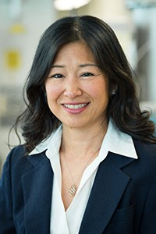Dr.Naoko Ellis
- Professor, Chemical and Biological Engineering, UBC
Dr. Naoko Ellis is a Professor in the Department of Chemical and Biological Engineering at UBC, the Acting Senior Research Director of Carbon Capture and Conversion Institute, a member of the Association of Professional Engineers and Geoscientists of BC, and a member of the Canadian Society for Chemical Engineering.
Her expertise lies in the area of multiphase reaction engineering with emphasis on fluidized beds. Specifically it includes: 1) Multiphase Systems and Reaction Engineering; 2) Chemical Looping Systems; 3) Biomass Utilization; 4) Bio-Oil Upgrading; 5) Biochar Potential; 6) Biodiesel Production. She has won the Scholarship of Teaching and Learning Leadership from UBC APSC Sustainability Pathway Initiative from 2013 to 2015. And she has been a UBC Sustainability Initiative Teaching & Learning Fellow since 2013. And she is passionate about engaging others on sustainability related issues, and developing ways to advance environmental literacy.
Speech subject: Biomass utilization: bio-oil upgrading and biochar for capacitative deionization
Abstract:
Bio-oil and biochar are produced through biomass pyrolysis of wood waste. Over the past 13 years, Ellis has worked on upgrading bio-oil through mixing with biodiesel. The resulting fuel has been tested in a single cylinder engine, highlighting the advantages and challenges of this type of biofuel. Biochar has been developed as: catalysts for esterification and transesterificaiton reactions; new material for electrodes for electric double layer application, i.e., capacitive deionization; and engineered fertilizers. Gasification of biomass allows production of syngas from which various chemicals and fuel are produced. However, biomass tar must be removed prior to downstream processing. Various catalysts are under investigation to clean the syngas to make the overall biomass gasification an attractive operation for biomass utilization.

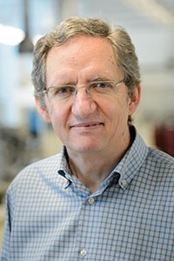Dr.Kevin Smith
- Professor, Chemical and Biological Engineering, UBC
Dr. Kevin Smith is a Professor in the Department of Chemical and Biological Engineering at UBC. The aim of his research is to better understand the relationships between heterogeneous catalyst properties, reaction kinetics and reaction mechanisms, so as to assist in the design and development of improved catalysts and catalytic processes. He focuses on issues related to the Canadian energy scene. Current research activities include an investigation of hydrogen production by catalytic methane decomposition, synthesis gas conversion to alcohols and hydrocarbons, residue and bio-oil hydroconversion (upgrading) as well as hydrogen storage using heteroaromatic liquids. His group's research approach is based mainly on experimental work. Catalysts are prepared and characterized and experiments are designed to elucidate reaction kinetics and mechanisms. This information is used to build kinetic models that reflect catalyst performance as a function of both the catalyst properties and the process conditions.
Speech subject: Catalysts for bio-oil upgrading and syngas conversion
Abstract:
A growing worldwide need for alternative fuels and chemicals has increased interest in biomass conversion by fast pyrolysis and gasification. Catalytic processes are used to upgrade pyrolysis oils via hydrodeoxygenation (HDO) and to convert synthesis gas to liquid fuels and chemicals. This seminar presents recent studies from our laboratory focused on the preparation, characterization and activity of several Mo-based catalysts for these upgrading reactions.
Using 4-methylphenol as a model reactant, the direct deoxygenation (DDO) versus hydrogenation (HYD) reaction pathways of HDO have been assessed over MoO_{x}, MoP, MoS₂ and Mo₂C catalysts. The rate of 4-methyphenol conversion is shown to be significantly higher over the MoP and Mo₂C catalysts, with the DDO selectivity highest over the Mo₂C catalyst. The impact of O in the case of Mo₂C is also discussed. The high selectivity of MoP catalysts for synthesis gas conversion to alcohols, taking advantage of the high hydrogenation activity of this catalyst, is also demonstrated.

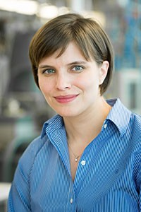Dr.Heather Trajano
- Assistant Professor, Chemical and Biological Engineering, UBC
Dr. Heather Trajano is an Assistant Professor of UBC Department of Chemical and Biological Engineering. She completed her Ph.D. degree from University of California Riverside in 2012. Her research interest is on flowthrough pretreatment of softwoods: fundamentals and applications, recovery and purification of extractives, and chemocatalytic conversion of biomass. The goal of her research is to make large-scale biorefineries a reality by examining and harnessing the fundamental kinetic and transport phenomena of fractionation and catalysis for maximum economic and environmental benefit.

Speech subject: Superior paper performance through waste recovery
Abstract: The focus of the Trajano Research Lab is to develop process technology for the production of chemicals from forest biomass that complements existing forest industry operations. These developments will require fundamental knowledge to enable process scale-up and prove economic viability. Dr. Trajano studies the fundamentals of recovering sugars from biomass and the catalytic conversion of those sugars into chemicals. These biomass-derived chemicals are a sustainable alternative to traditional petrochemicals. She also studies the recovery and purification of speciality compounds from biomass for use in fragrances, vitamins, and pharmaceuticals. These technologies will renew the forestry industry, create jobs in nearby rural communities, and contribute to the low-carbon economy transformation.
British Columbia’s pulp is some of the strongest in the world and commands a premium price in the global marketplace. In partnership with Canfor Pulp Products, Dr. Trajano is exploring how to recover polysaccharides from wood waste to make a green paper strength additive to further enhance pulp performance. The effects of feedstock, temperature and time on polysaccharide recovery from wood waste will be described. The effects of adsorption of model polysaccharides and polysaccharides from wood waste on paper properties will be presented.

